Appendix I

Internship Time Sheet and Report – Damian Satya Wibowo 58090002

Job description: implementing IoT in an air conditioner to control the air conditioner remotely, publishing the air conditioner’s status and surrounding environment data (temperature, current) online, also logging the sensor data inside a server.

Day 1 – 06/04 Mo 0915~1425 (5 hours 10 minutes, cumulative: 5 h 10 m)

1. Briefing about introduction to the company and its projects

2. Discussing with some managers and employees

3. Choosing one project which suits both the intern and the company

*06/05 Tu~06/08 Fr Undergone a nail surgery (4-day leave)*

*06/11 Mo~06/21 Th Eid-al-Fitr national holiday*

Day 2 – 06/22 Fr 1545~1915 (3 hours 30 minutes, cumulative: 8 h 40 m)

4. Setting up device environment (Cayenne, Qt, VNC Viewer)

5. Obtaining Raspberry Pi

Day 3 – 06/23 Sa 1005~1530 (5 hours 25 minutes, cumulative: 14 h 05 m)

6. Buying necessities for work (LAN cable, LAN-to-USB cable, power supply cable)

7. Setting up Raspberry Pi and connections

Day 4 – 06/25 Mo 0840~1702 (8 hours 22 minutes, cumulative: 22 h 27 m)

8. Helping other interns setting up Cayenne and connections between Pi and notebooks

9. Working on GPIO controls

10. Discussing about which components to use

11. Integrating Qt and Cayenne MQTT API

Day 5 – 06/26 Tu 0830~1630; 1725~1835 (9 hours 10 minutes, cumulative: 31 h 37 m)

12. Drew the mapping between AC, SCT013 current sensor, Si7021 temperature sensor, AD7124 analog-digital converter, Raspberry Pi and TSOP4838 infrared receiver.

13. Consulting with an employee in constructing the PCB for modules and junction boards

14. Making SPI communication to work

15. Also obtaining Si7021-Pi and AD7124-Pi codes

16. Setting up MQTT communication prototype via Mosquitto library

17. Learning and reading HTML5 and PHP for building the web interface

18. Stopping development in Cayenne application

*Figure 1. Simple schema*

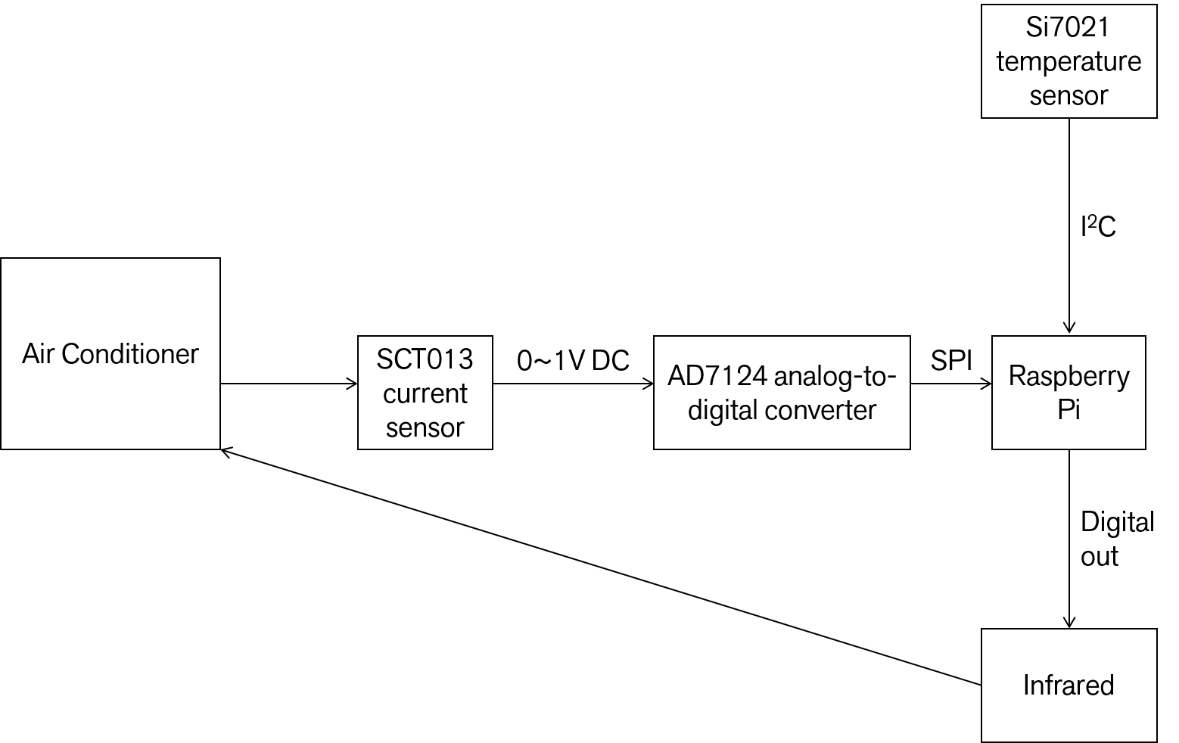

*Figure 2. Enhanced Schema*

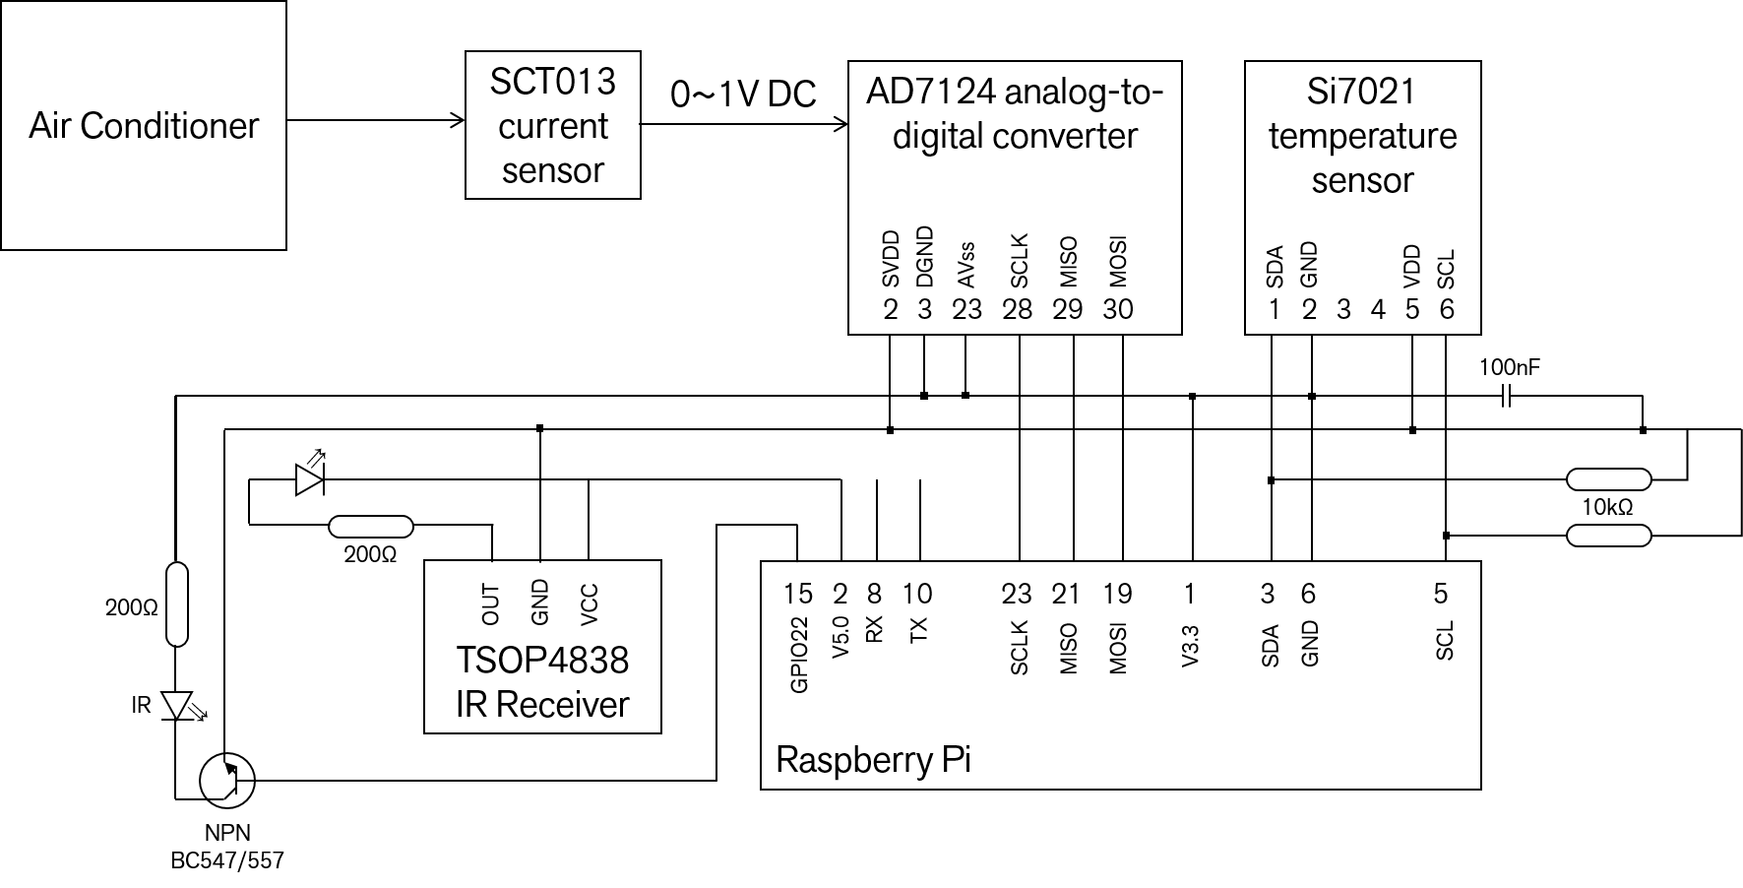

*06/27 We National Holiday (2018 Simultaneous Elections’ day)*

Day 6 – 06/28 Th0900~1620; 1710~1850 (9 hours 0 minutes, cumulative: 40 h 37 m)

19. Continuing to study HTML5 and JavaScript

20. Testing out Pi GPIO inputs and outputs, also interrupts

21. Testing IR input and output. Input worked already

22. Mapped embedded system with server and client side

23. Waiting for the modules to be shipped to the office

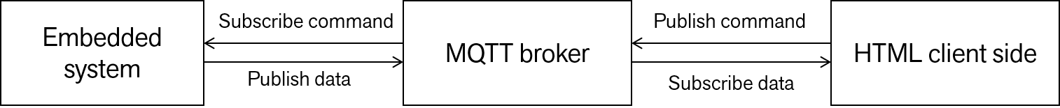

Day 7 – 06/29 Fr0820~1620 (8 hours 0 minutes, cumulative: 48 h 37 m)

23. Still waiting for the modules to be shipped to the office

24. Completed the simulation of client-side HTML/JS control and status page

25. Mapping IR inputs and trying to connect IR output

26. Learning how to send/receive data via MQTT and outputting in HTML/JS

*07/02 Mo One-day sick leave*

Day 8 – 07/03 Tu0834~1744; 1856~2006 (10 hours 20 minutes, cumulative: 58 h 57 m)

23. Still waiting for the modules to be shipped to the office

27. Finished IR transmitter/receiver prototype

28. Starting MQTT-HTML-JS integration prototype

29. Trying to connect a customized AD7124 ADC module to Raspberry Pi

Day 9 – 07/04 We0823~1708 (8 hours 45 minutes, cumulative: 67 h 42 m)

23. Still waiting for the modules to be shipped to the office

29. Still trying Pi-ADC connections through SPI

30. Improving MQTT-HTML-JS integration prototype (MQTT AC control and status panel prototype)

31. Working on MQTT C++ API for handling MQTT clients in Raspberry Pi

Day 10 – 07/05 Th0831~1633; 1805~1857 (8 hours 54 minutes, cumulative: 76 h 36 m)

23. Still waiting for the modules to be shipped to the office

29. Still trying to establish communication between AD7124 ADC with Pi through SPI, failed although using many different libraries

32. Finishing MQTT-HTML-JS communication prototype

Day 11 – 07/06 Fr0824~1929 (11 hours 5 minutes, cumulative: 87 h 41 m)

23. Still waiting for the modules to be shipped to the office

29. Still trying to establish communication between AD7124 ADC with Pi through SPI

33. Finished MQTT-HTML-JS communication prototype

34. Implemented a simple Request-Response acknowledgement system in MQTT

35. Starting documentation

36. Hearing some talk about communication/software interception through serial monitor and disassembler

37. Meeting with the project manager about the re-conception of the project and the usage of development board

Day 12 – 07/09 Mo0912~1724; 1818~1943 (9 hours 37 minutes, cumulative: 97 h 18 m)

23. Still waiting for the modules to be shipped to the office

29. Still trying to establish communication between AD7124 ADC with Pi through SPI

38. Continuing documentation: Rewriting requirements

39. Hearing some tutorial on SPI communication from a staff

40. Doing exercise about SPI connection between Raspberry Pi~Micro SD reader

Day 13 – 07/10 Tu0852~1741 (8 hours 49 minutes, cumulative: 106 h 7 m)

29. Still trying to establish communication between AD7124 ADC with Pi through SPI (paused)

41. Continuing documentation: Program flow diagram for HTML control page

42. Moving to development board with a new set of IR and temperature sensors

43. Connecting Si7021 temperature sensor and Pi through I2C, but the hardware solders were loose at the end

44. Studying about PHP5 and Postgre/MySQL for server communication and database

45. Installed a PHP web server in localhost

Day 14 – 07/11 We0854~1738 (8 hours 44 minutes, cumulative: 114 h 51 m)

46. Continuing documentation: Program flow diagram for all remaining programs

47. Structuring database design for storing sensor data

48. One of the staff corrected the soldering in the I2C circuit

49. Connected new IR receiver and blaster modules

50. Invited to a tutorial by PT. Cinovasi Rekaprima (related company) about module kits, their characteristics and programming styles

51. Adding file I/O to contain sensor readings

Day 15 – 07/12 Th0840~1744 (9 hours 4 minutes, cumulative: 123 h 55 m)

46. Continuing documentation: Program flow diagram for all remaining programs

52. Debugging IR sending/receiving mechanism and real mapping (although no remotes were given) using Xiaomi Remote for LG AC and assuming baud rate = 38000 Hz

53. Completed IR sending/receiving device

54. Completed temperature sensor communication and file I/O to Pi

55. Invited to second tutorial at PT. Cinovasi Rekaprima about software and hardware control

Day 16 – 07/13 Fr0842~1727 (8 hours 45 minutes, cumulative: 132 h 40 m)

56. Continuing documentation: some of code descriptions

57. Debugged and improved HTML control code and Raspberry IoT driver

58. Invited to third tutorial by PT. Cinovasi Rekaprima about data flow

Day 17 – 07/16 Mo0844~1724 (8 hours 40 minutes, cumulative: 141 h 20 m)

59. Establishing a local web server containing ctrl.html file (which later was renamed as index.php)

60. Learning more PHP/SQL and C for integration (putting sensor data to the server)

61. Progress report meeting with the president of the company

62. Debugging SPI and I2C connections using oscilloscope

63. Trying to connect MySQL API to the real MySQL server database (failed)

Day 18 – 07/17 Tu0839~1701; 1753~1851 (9 hours 20 minutes, cumulative: 150 h 40 m)

64. Moving to ADS1115 Analog-to-Digital module (I2C), replacing the formerly failed AD7124

65. Calibrated and converted ADS1115 Analog-to-Digital module

66. Finished connection and reading of ADS1115 Analog-to-Digital module, (later got short circuit)

67. Learning about how to log sensor data into a remote server via PHP/HTML GET

Day 19 – 07/18 We0843~1413 (5 hours 30 minutes, cumulative: 156 h 10 m)

68. Putting PHP prototype script for posting and retrieving data to/from the remote web server

69. Converting the prototype into the real application

70. Trying to use libcurl to post simulated sensor data via PHP/HTML GET (accomplished)

71. Moving webhost to the one which supports cURL

Day 20 – 07/19 Th1506~2046 (5 hours 40 minutes, cumulative: 161 h 50 m)

72. Integrating LIRC commands and mainSys.c

73. Doing further documentation (file list, function lists, credentials, etc.)

74. Improving coding styles for all programs

Day 21 – 07/20 Fr0841~1858 (10 hours 17 minutes, cumulative: 172 h 7 m)

74. Improving coding styles for all programs

75. Integrating temperature sensor and mainSys.c

76. Updating documentation (flowcharts, function lists, file list)

77. Setting a periodic temperature reading (cron job)

78. Sending periodic sensor data to the server

79. Setting ctrl.html to read sensor periodically as well

Day 22 – 07/22 Su0905~1808 (9 hours 3 minutes, cumulative: 181 h 10 m)

74. Improving coding styles for all programs

80. Rearranging and updating documentation

81. Removing unnecessary debug codes

82. Cleaning up unnecessary files and rearranging files and links

83. Starting to compose the report

Day 23 – 07/23 Mo0840~1737 (8 hours 57 minutes, cumulative: 190 h 7 m)

74. Improving coding styles for all programs

80. Rearranging and updating documentation

84. Configuring and calibrating a new ADS1115 analog-to-digital converter (got voltage reading)

85. Reintroducing AD7124 ADC module for testing

86. Reporting and consulting the project to the company president

87. Moving all programming environment to Qt and C++ OOP, plus threading and synchronization

88. Starting second phase of development (prototype 2) so that the server (logging) will be integrated to the main system

89. Was given a new customized web server engine (QtWebApp)

90. Moved Mainsys.c into MainApp in Qt (Pi)

91. Moved I2C initialization into a separate class

92. Reconfiguring Qt (desktop) to support Visual Studio 2017 compiler

Day 24 – 07/24 Tu0855~1856 (10 hours 1 minute, cumulative: 200 h 8 m)

92. Reconfiguring Qt (desktop) to support Visual Studio 2017 compiler

93. Integrated temperature and voltage reading programs to the I2C class

94. Getting the current sensor module TBN061807007/56T100C

95. Testing current sensor module and small modification by a staff

96. Was given a potentiometer as a simulation for ADC reading

97. Calibrating current sensor module (found a hardware fault)

98. Studying and experimenting the web engine given

99. Starting to draw UML class diagrams

100. Redesigning and reconfiguring the web application

101. Conceptualizing a new web-based controller and logger which is MQTT-independent

Day 25 – 07/25 We0853~1722 (8 hours 29 minutes, cumulative: 208 h 38 m)

102. Consulting with the head of the company about how to link the web server to a database

103. Writing a new documentation for the new system

104. Building the new web controller

105. Was given an integrated MQTT-web server engine library

106. Attended about a comparative talk with PT. Cinovasi Rekaprima’s interns and supervisor who are developing a similar project

107. Migrating the older prototype to the new system

Day 26 – 07/26 Th0921~1602; 1801~2119 (9 hours 59 minutes, cumulative: 218 h 37 m)

97. Calibrating current sensor module

103. Writing a new documentation for the new system

107. Migrating the older prototype to the new system

108. Composing reports, both for the company and for KMITL

109. Not yet connected the current sensor, but integrated the programs so that the current can now be outputted

110. Moving to Qt with MinGW compiler

111. Reconfiguring the given source code

Day 27 – 07/27 Fr0923~1610 (6 hours 47 minutes, cumulative: 225 h 24 m)

107. Migrating the older prototype to the new system

108. Composing reports, both for the company and for KMITL

112. Getting help debugging the new source code template (library not detected)

Day 28 – 07/28 Sa0931~1507 (5 hours 36 minutes, cumulative: 231 h 0 m)

107. Migrating the older prototype to the new system

108. Composing reports, both for the company and for KMITL

113. Reformulating MQTT message formats and logic flow

114. Getting confused about how the second phase will be carried out

Day 29 – 07/29 Su 1303~1445; 1835~2201 (5 hours 8 minutes, cumulative: 236 h 8 m)

108. Composing reports, both for the company and for KMITL

115. Redesigning server-HTML communication mechanism

116. Revising all requirements

Day 30 – 07/30 Mo 0904~1656 (7 hours 52 minutes, cumulative: 244 h 0 m)

108. Composing reports, both for the company and for KMITL

117. Figuring out why Mosquitto cannot connect to the server via the new framework

118. Getting help from the head of the company for integrating QWebApp and MQTT app

119. Uniting president’s code and my code

Day 31 – 07/31 Tu 1017~1721 (7 hours 4 minutes, cumulative: 251 h 4 m)

108. Composing reports, both for the company and for KMITL

120. Improving the code

121. Continuing the new documentation

Day 32 – 08/01 We 0847~xx (xx hours xx minutes, cumulative: x h x m)

108. Composing reports, both for the company and for KMITL

120. Improving the code

121. Continuing the new documentation

122. Cleaning unnecessary files and directories to be presented